DRAFT
Oyster Density Interpolations on Oyster Reefs
Identified as Restorable in the Lafayette River, Virginia
8/26/2015

Objectives
Ten relict oyster reefs were sampled with patent tongs by the Virginia Institute of Marine Sciences and Christopher Newport University in 2014. Within these 10 reefs, 13 sites were identified as restorable (map below; also see DRAFT Lafayette River Restorable Bottom Summary 03-02-2015; Appendix I, pages 7 & 8).
Patent tong sample data were interpolated to determine the proportion of area in the 13 sites that met the 15 and 50 oyster density (number/m² & grams dry wt. /m²) restoration thresholds.
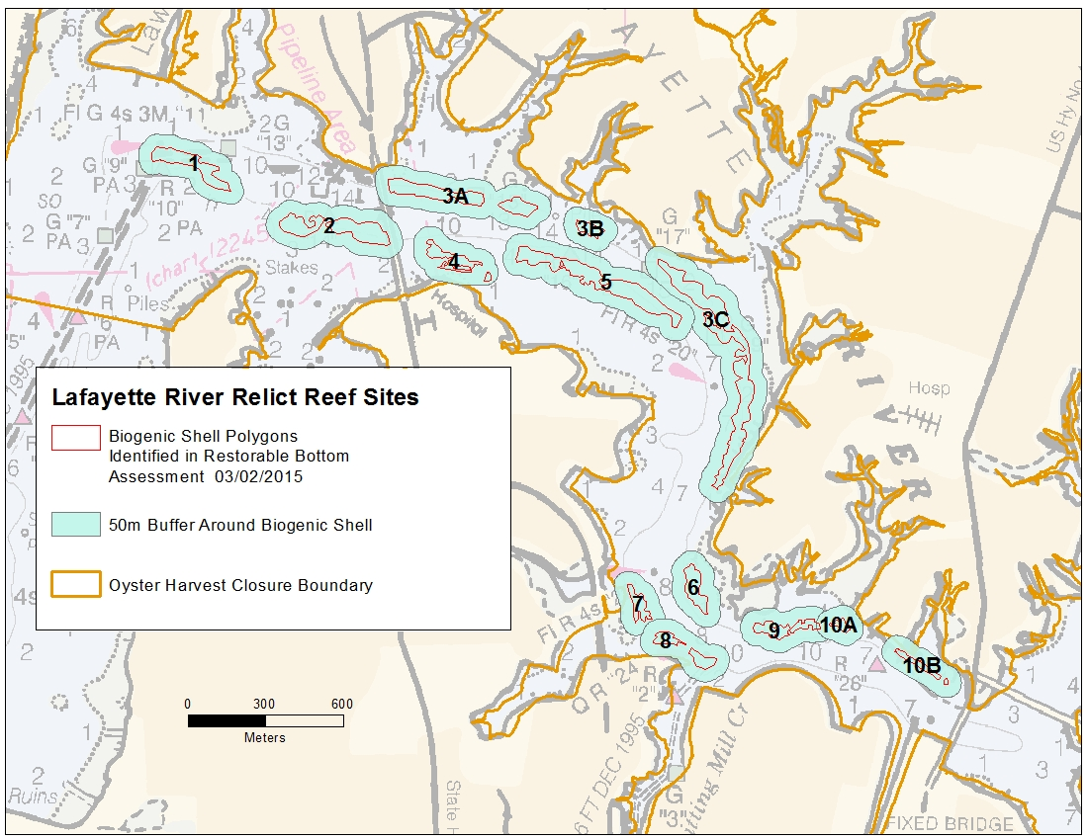
Results

Density Parameter: Number Oysters (all sizes) Per Square Meter
Site Name | Area Acres | Area Sq. meters | Tot. Area from interpolated grid (no. 1x1 m grid cells) | Sum grid cells (meters sq.) with density value < 15 | Sum grid cells (meters sq.) with density value >= 15 | Sum of grid cells (meters sq.) with density value >= 50 | Percent area with density value < 15 | Percent area with density value >= 15 | Percent area with density value >= 50
1 | 3.7 | 15151.9 | 15150 | 381 | 14769 | 8602 | 2.5 | 97.5 | 56.8
2 | 5.7 | 23246.6 | 23243 | 0 | 23243 | 16726 | 0.0 | 100.0 | 72.0
3A | 5.6 | 22746.2 | 22738 | 732 | 22006 | 15107 | 3.2 | 96.8 | 66.4
3B | 0.9 | 3844.4 | 3837 | 0 | 3837 | 3244 | 0.0 | 100.0 | 84.5
3C | 12.1 | 49066.6 | 49057 | 10213 | 38844 | 9617 | 20.8 | 79.2 | 19.6
4 | 2.3 | 9471.0 | 9471 | 46 | 9425 | 8411 | 0.5 | 99.5 | 88.8
5 | 8.5 | 34531.7 | 34519 | 106 | 34413 | 26753 | 0.3 | 99.7 | 77.5
6 | 2.2 | 8957.9 | 8938 | 134 | 8804 | 7578 | 1.5 | 98.5 | 84.8
7 | 1.4 | 5670.6 | 5685 | 0 | 5685 | 4686 | 0.0 | 100.0 | 82.4
8 | 1.9 | 7500.6 | 7503 | 592 | 6911 | 878 | 7.9 | 92.1 | 11.7
9 | 2.1 | 8673.1 | 8658 | 279 | 8379 | 5826 | 3.2 | 96.8 | 67.3
10A | 0.5 | 1992.4 | 1994 | 1 | 1993 | 1600 | 0.1 | 99.9 | 80.2
10B | 1.0 | 4043.6 | 4049 | 620 | 3429 | 995 | 15.3 | 84.7 | 24.6
All Sites Pooled | 48.2 | 194896.6 | 194842 | 13104 | 181738 | 110023 | 6.7 | 93.3 | 56.5
 |  |  |  |  |  |  | Above the 30% threshold
 |  |  |  |  |  |  | Below the 30% threshold

Results (continued)

Density Parameter: Grams Dry Weight (all sizes) Per Square Meter
Site Name | Area Acres | Area Sq. meters | Tot. Area from interpolated grid (no. 1x1 m grid cells) | Sum grid cells (meters sq.) with density value < 15 | Sum grid cells (meters sq.) with density value >= 15 | Sum of grid cells (meters sq.) with density value >= 50 | Percent area with density value < 15 | Percent area with density value >= 15 | Percent area with density value >= 50
1 | 3.7 | 15151.9 | 15150 | 925 | 14225 | 2219 | 6.1 | 93.9 | 14.6
2 | 5.7 | 23246.6 | 23243 | 0 | 23243 | 12419 | 0.0 | 100.0 | 53.4
3A | 5.6 | 22746.2 | 22738 | 4180 | 18558 | 12638 | 18.4 | 81.6 | 55.6
3B | 0.9 | 3844.4 | 3837 | 0 | 3837 | 1872 | 0.0 | 100.0 | 48.8
3C | 12.1 | 49066.6 | 49057 | 2777 | 46280 | 21711 | 5.7 | 94.3 | 44.3
4 | 2.3 | 9471.0 | 9471 | 126 | 9345 | 6677 | 1.3 | 98.7 | 70.5
5 | 8.5 | 34531.7 | 34519 | 201 | 34318 | 23353 | 0.6 | 99.4 | 67.7
6 | 2.2 | 8957.9 | 8938 | 158 | 8780 | 7367 | 1.8 | 98.2 | 82.4
7 | 1.4 | 5670.6 | 5685 | 0 | 5685 | 5253 | 0.0 | 100.0 | 92.4
8 | 1.9 | 7500.6 | 7503 | 233 | 7270 | 890 | 3.1 | 96.9 | 11.9
9 | 2.1 | 8673.1 | 8658 | 392 | 8266 | 7336 | 4.5 | 95.5 | 84.7
10A | 0.5 | 1992.4 | 1994 | 3 | 1991 | 1751 | 0.2 | 99.8 | 87.8
10B | 1.0 | 4043.6 | 4049 | 300 | 3749 | 2051 | 7.4 | 92.6 | 50.7
All Sites Pooled | 48.2 | 194896.6 | 194842 | 9295 | 185547 | 105537 | 4.8 | 95.2 | 54.2
 |  |  |  |  |  |  | Above the 30% threshold
 |  |  |  |  |  |  | Below the 30% threshold

Methods
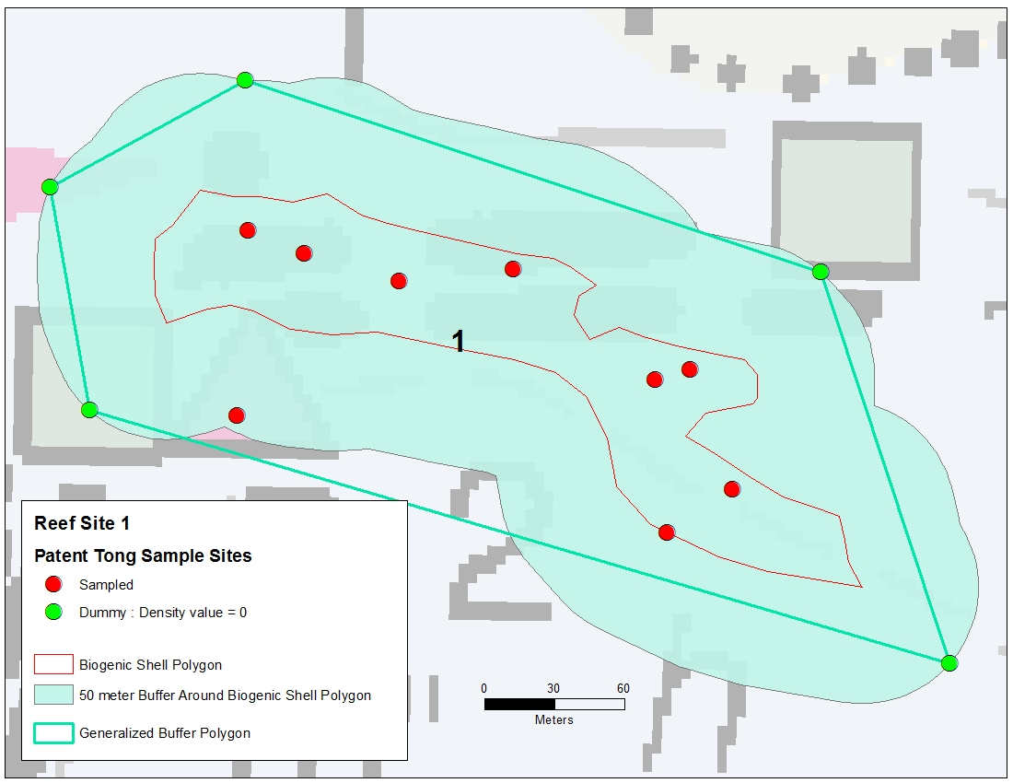
- Biogenic shell polygons (red above) were identified as restorable in the DRAFT Lafayette River Restorable Bottom Summary 03-02-2015 (Appendix I, pages 7 & 8)
- 50 meter buffer polygons (light blue above) were created around the shell polygons. Any patent tong sampling points outside of the 50 m buffer were deleted.
- Generalized polygons (aqua line above) were created from the 50m buffer using a 50m generalization distance (Douglass-Poiker algorithm in ET Geowizards GIS Extension).
- Dummy points (green above), located at the vertices of the generalized polygons, were added to the patent tong sampling data, and were assigned values of zero. This was done to ensure that the oyster density interpolations extended beyond the outermost sampling points and covered the entire biogenic shell polygon

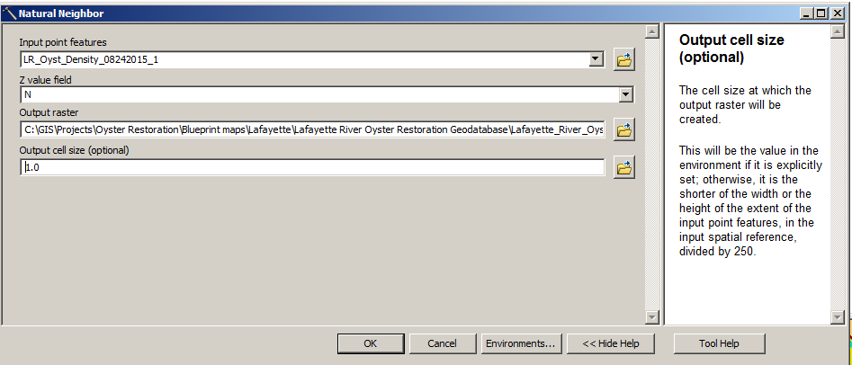
- Patent tong oyster density data were interpolated with the Natural Neighbor method (above). The output grid (below) had 1x1 m cell dimensions.
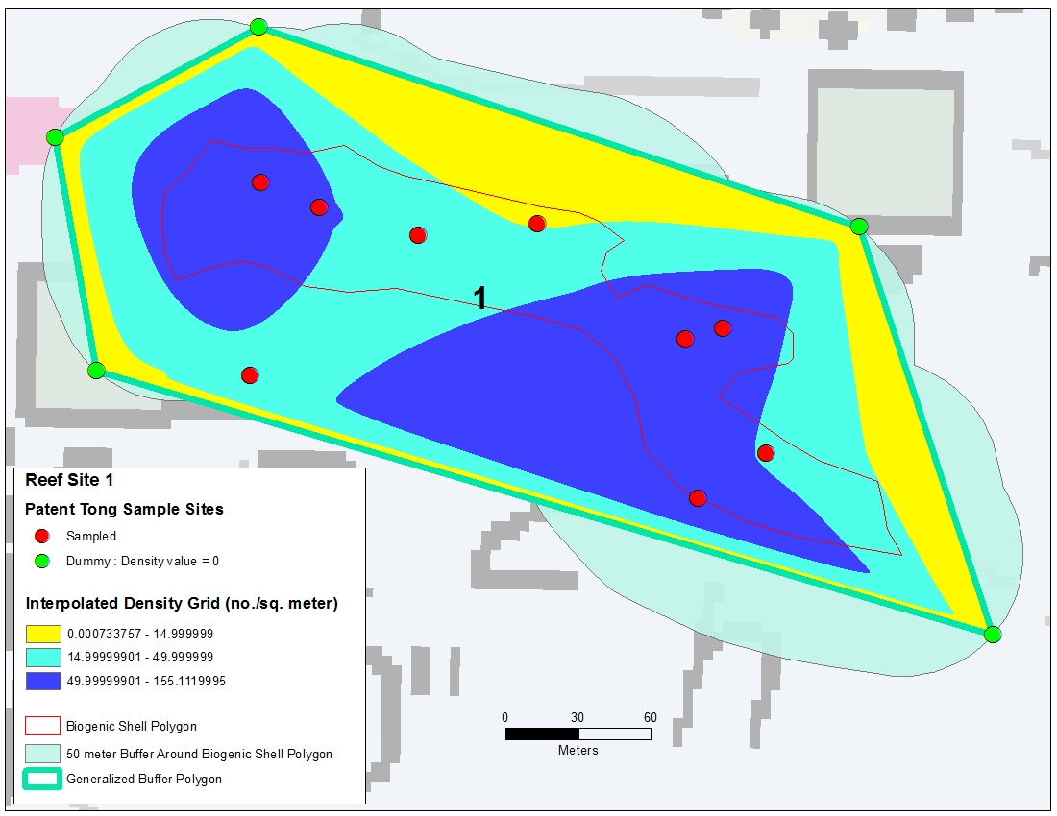

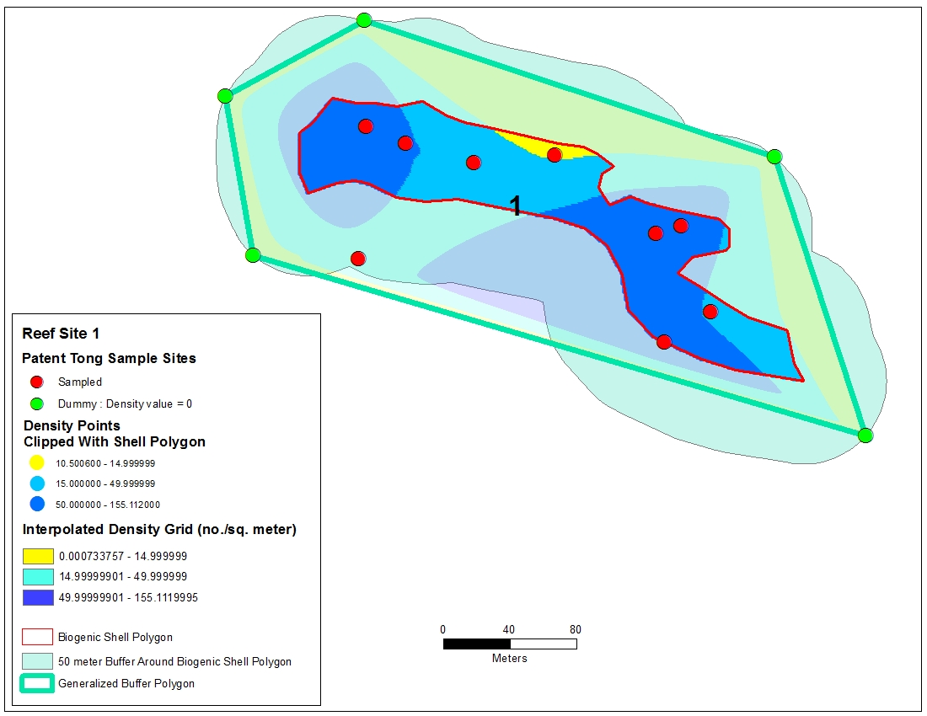
- Density grid cells were converted to points and clipped with the biogenic shell polygon (above). For each of the 13 sites, density values were binned into the following intervals: < 15.0, 15.0-49.9,>= 50.0. The results are summarized in pages 2 and 3.

Appendix I: DRAFT Lafayette River Restorable Bottom Summary 03-02-2015
Lafayette River Restorable Bottom Criteria:
- 2012 Survey Extent + CBF & ERP shallow water restoration sites
2) Minimum depth: 3.3 ft MLLW, maximum depth : 16.5 ft.
3) Seabed types
-Anthropogenic Shell Rubble
-Biogenic Shell Rubble, and shell rubble with sand or mud
-Constructed 3D shell reefs
-Muddy Sand with hard subsurface sediments
-Other reefs (reef balls & unknown material)
-Unclassified bottom with hard subsurface sediments
NOTE: Areas of Biogenic Shell Rubble with mud that lacked strong acoustic signatures of surface shell (single beam seabed classification) and had < 15 live oysters per sq. meter were excluded.
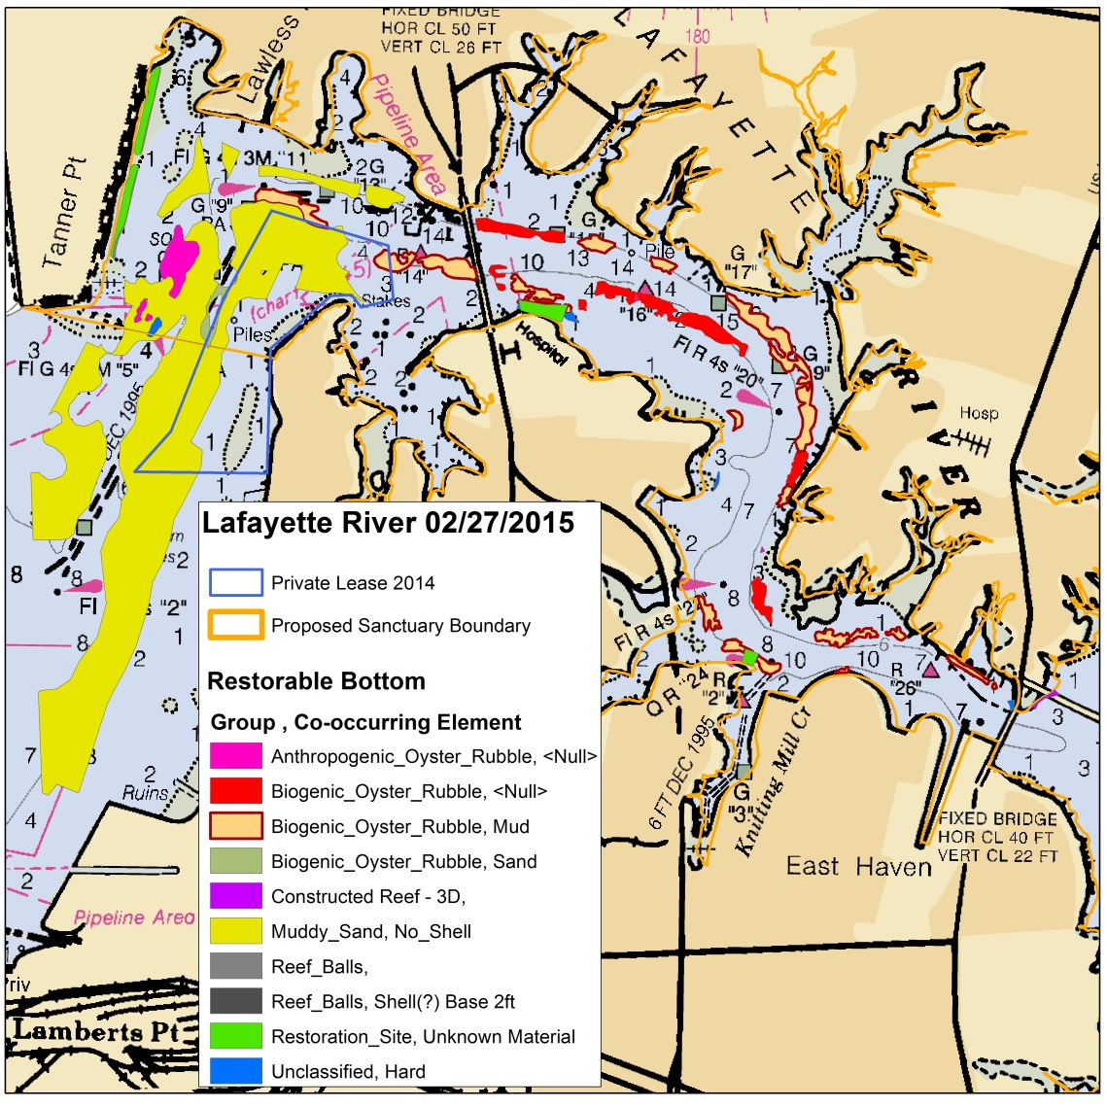
Lafayette River Restorable Bottom Area Summary Statistics 02-27-2015
 |  |  | Area (Acres)
Sanctuary | Group | Co-Occurring Element | Mean | Std. Dev. | Min |  | Max |  | Total Area |  |  | Number of Polygons
Inside | Anthropogenic_Oyster_Rubble | <Null> | 2.1 | 3.6 | 0.1 |  | 6.2 |  | 6.3 |  |  | 3
Inside | Biogenic_Oyster_Rubble | <Null> | 3.0 | 3.0 | 0.4 |  | 8.5 |  | 17.7 |  |  | 6
Inside | Biogenic_Oyster_Rubble | Mud | 1.5 | 2.2 | 0.0 |  | 9.8 |  | 32.5 |  |  | 22
Inside | Biogenic_Oyster_Rubble | Sand | 2.4 |  | 2.4 |  | 2.4 |  | 2.4 |  |  | 1
Inside | Constr. Reef - 3D Shell | <Null> | 0.3 | 0.2 | 0.2 |  | 0.6 |  | 1.3 |  |  | 4
Inside | Muddy_Sand | No_Shell | 15.2 | 25.9 | 1.4 |  | 61.5 |  | 75.8 |  |  | 5
Inside | Reef_Balls | <Null> | 0.2 | 0.2 | 0.0 |  | 0.5 |  | 0.9 |  |  | 6
Inside | Restoration_Site | Unknown | 2.1 | 0.9 | 0.7 |  | 2.7 |  | 8.2 |  |  | 4
Inside | Unclassified | Hard | 0.2 | 0.2 | 0.0 |  | 0.5 |  | 1.5 |  |  | 6
 |  |  |  | Total area within sanctuary = |  |  |  |  |  |  | 146.5
 |  |  | Area (Acres)
Sanctuary | Group | Co-Occurring Element | Mean | Std. Dev. | Min |  | Max |  | Total Area |  |  | Number of Polygons
Outside | Biogenic_Oyster_Rubble | Sand | 0.0 |  | 0.0 |  | 0.0 |  | 0.0 |  |  | 1
Outside | Constr. Reef - 3D Shell | <Null> | 0.0 |  | 0.0 |  | 0.0 |  | 0.0 |  |  | 1
Outside | Muddy_Sand | No_Shell | 146.4 |  | 146.4 |  | 146.4 |  | 146.4 |  |  | 1
Outside | Reef_Balls | <Null> | 0.0 |  | 0.0 |  | 0.0 |  | 0.0 |  |  | 1
Outside | Restoration_Site | Unknown | 0.0 | 0.0 | 0.0 |  | 0.0 |  | 0.1 |  |  | 4
Outside | Unclassified | Hard | 0.1 |  | 0.1 |  | 0.1 |  | 0.1 |  |  | 1
 |  |  |  | Total area outside sanctuary = |  |  |  |  |  |  | 146.6

NOTE: Both Rom Lipcius and Tommy Legget have commented that the lower Lafayette, South of Tanner Pt. and the proposed sanctuary boundary, may be subject to very dynamic current conditions that may lead to sedimentation and covering of any restoration activities. The 2012&2014 NCBO surveys cannot prove or disprove this. Additional ground truthing, preferably with ROV/video, should provide insight to this issue, if this area is to be included in project planning.

