**03-02-2015**

**Lafayette River Restorable Bottom Criteria:**

1. 2012 Survey Extent + CBF & ERP shallow water restoration sites

2) Minimum depth: 3.3 ft MLLW, maximum depth : 16.5 ft.

3) Seabed types

-Anthropogenic Shell Rubble

-Biogenic Shell Rubble, and shell rubble with sand or mud

-Constructed 3D shell reefs

-Muddy Sand with hard subsurface sediments

-Other reefs (reef balls & unknown material)

-Unclassified bottom with hard subsurface sediments

NOTE: Areas of Biogenic Shell Rubble with mud that lacked strong acoustic signatures of surface shell (single beam seabed classification) and had < 15 live oysters per sq. meter were excluded.

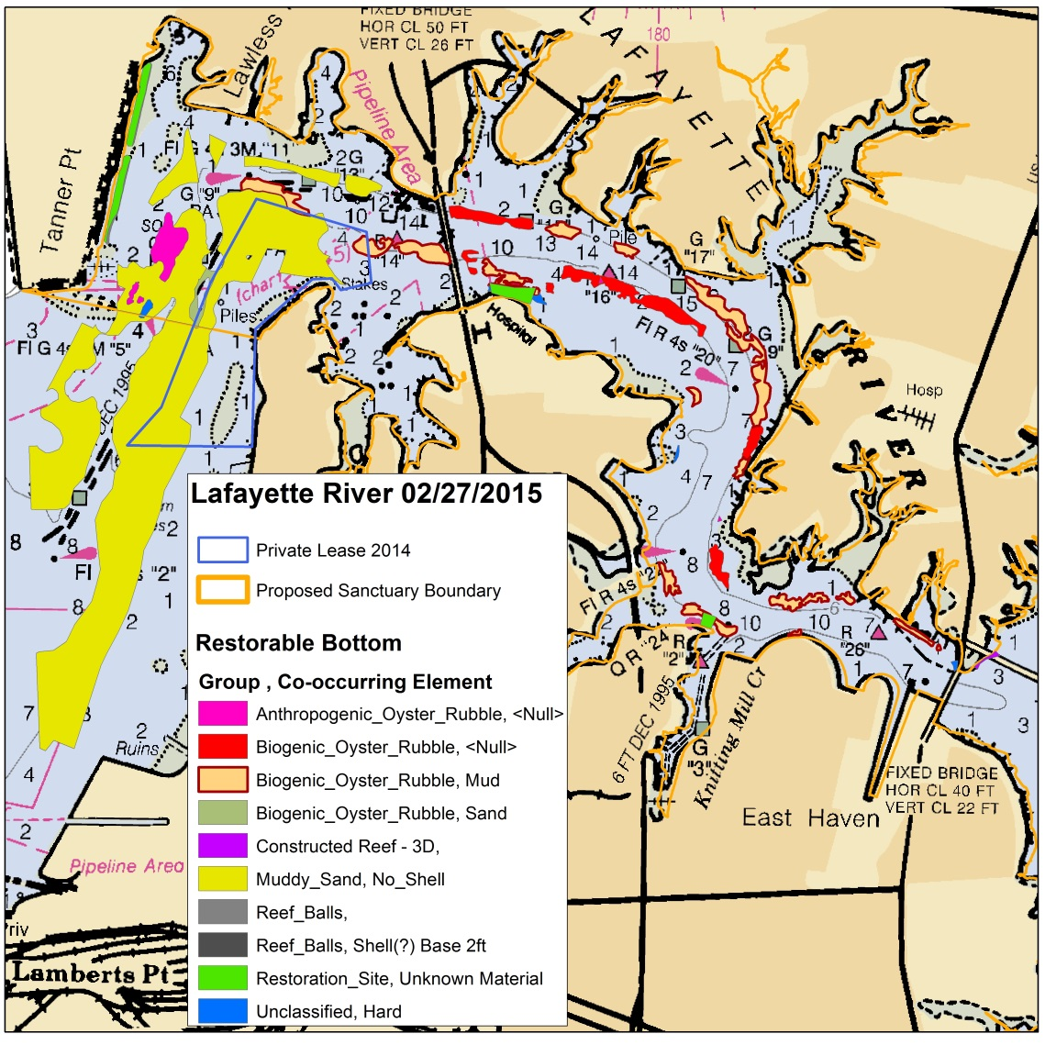

|  |  |  |  |  |  |  |  |  |  |  |  |  |  |  |
| --- | --- | --- | --- | --- | --- | --- | --- | --- | --- | --- | --- | --- | --- | --- |
| Lafayette River Restorable Bottom Area Summary Statistics 02-27-2015 | | | | | | | | | | | | | | |
|
|  |  |  | Area (Acres) | | | | | | | | | |  | |
| Sanctuary | Group | Co-Occurring Element | Mean | Std. Dev. | Min | | Max | | Total Area | | | Number of Polygons | |
| Inside | Anthropogenic_Oyster_Rubble | <Null> | 2.1 | 3.6 | 0.1 | | 6.2 | | 6.3 | | | 3 | |
| Inside | Biogenic_Oyster_Rubble | <Null> | 3.0 | 3.0 | 0.4 | | 8.5 | | 17.7 | | | 6 | |
| Inside | Biogenic_Oyster_Rubble | Mud | 1.5 | 2.2 | 0.0 | | 9.8 | | 32.5 | | | 22 | |
| Inside | Biogenic_Oyster_Rubble | Sand | 2.4 |  | 2.4 | | 2.4 | | 2.4 | | | 1 | |
| Inside | Constr. Reef - 3D Shell | <Null> | 0.3 | 0.2 | 0.2 | | 0.6 | | 1.3 | | | 4 | |
| Inside | Muddy_Sand | No_Shell | 15.2 | 25.9 | 1.4 | | 61.5 | | 75.8 | | | 5 | |
| Inside | Reef_Balls | <Null> | 0.2 | 0.2 | 0.0 | | 0.5 | | 0.9 | | | 6 | |
| Inside | Restoration_Site | Unknown | 2.1 | 0.9 | 0.7 | | 2.7 | | 8.2 | | | 4 | |
| Inside | Unclassified | Hard | 0.2 | 0.2 | 0.0 | | 0.5 | | 1.5 | | | 6 | |
|  |  |  |  | Total area within sanctuary = | | | | | | | 146.5 | |  | |
|  |  |  |  |  | |  | |  | |  |  | |  | |
|  |  |  | Area (Acres) | | | | | | | | | |  | |
| Sanctuary | Group | Co-Occurring Element | Mean | Std. Dev. | Min | | Max | | Total Area | | | Number of Polygons | |
| Outside | Biogenic_Oyster_Rubble | Sand | 0.0 |  | 0.0 | | 0.0 | | 0.0 | | | 1 | |
| Outside | Constr. Reef - 3D Shell | <Null> | 0.0 |  | 0.0 | | 0.0 | | 0.0 | | | 1 | |
| Outside | Muddy_Sand | No_Shell | 146.4 |  | 146.4 | | 146.4 | | 146.4 | | | 1 | |
| Outside | Reef_Balls | <Null> | 0.0 |  | 0.0 | | 0.0 | | 0.0 | | | 1 | |
| Outside | Restoration_Site | Unknown | 0.0 | 0.0 | 0.0 | | 0.0 | | 0.1 | | | 4 | |
| Outside | Unclassified | Hard | 0.1 |  | 0.1 | | 0.1 | | 0.1 | | | 1 | |
|  |  |  |  | Total area outside sanctuary = | | | | | | | 146.6 | |  | |

NOTE: Both Rom Lipcius and Tommy Legget have commented that the lower Lafayette, South of Tanner Pt. and the proposed sanctuary boundary, may be subject to very dynamic current conditions that may lead to sedimentation and covering of any restoration activities. The 2012&2014 NCBO surveys cannot prove or disprove this. Additional ground truthing, preferably with ROV/video, should provide insight to this issue, if this area is to be included in project planning.